# CS 255 System Design Document Template

This template lays out all the different sections that you need to complete for Project Two. Each section has guidance to prompt your thinking. You will need to continually reference the interview transcript as you work to make sure that you are addressing your client’s needs. There is no required length for the final document. Instead the goal is to complete each section based on what your client’s needs are. Remove this note when you are finished, and replace all bracketed text with the relevant information.

## UML Diagrams

### UML Use Case Diagram

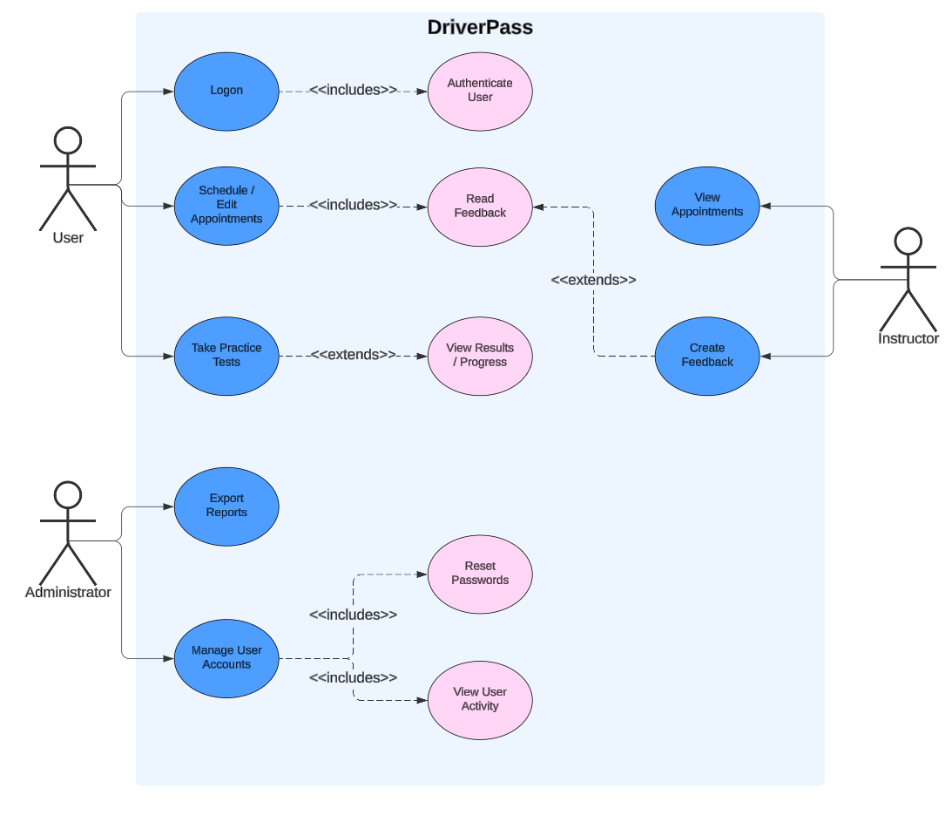

### UML Activity Diagrams

Logon Activity Diagram:

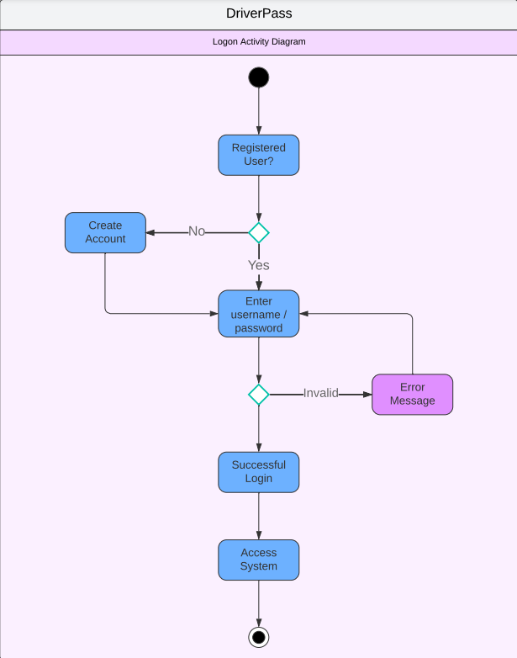

Manage User Accounts Diagram:

### UML Sequence Diagram

Logon Sequence:

### UML Class Diagram

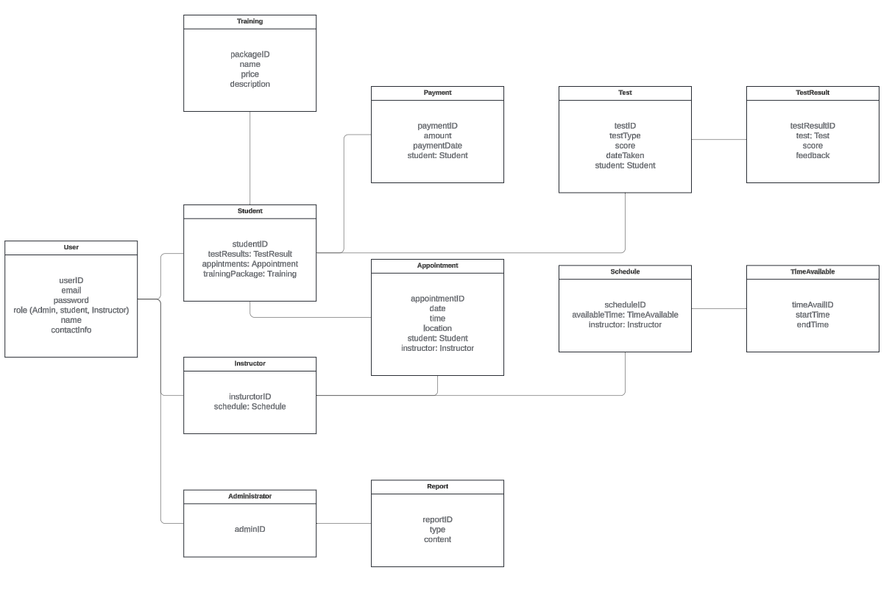

## Technical Requirements

This system will require a few pieces to function properly. The first will be some sort of database, preferably a cloud-based one, to hold the data created by the application and the users. This database will connect to a web server, hosting the code that builds and maintains the application's user interface and logic portion. When building this application, the developers will need a suite of software to include an IDE, some sort of source code scanning software, as well as a testing environment to ensure the system is functioning properly before going live to the users. Initially, this will be a relatively lightweight infrastructure but will have the potential to scale using a cloud environment.